**HW5**

**Question 1**

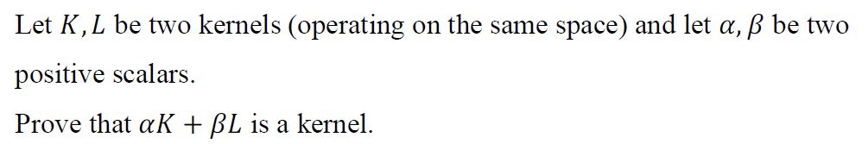

Proof:

Denote $K,L:R^{n}→R$ be the kernels.

By kernel definition, $∃φ_{1}:R^{n}→R^{N_{1}}, φ_{2}:R^{n}→R^{N_{2}} such that ∀x,y∈R^{n}:$

$$K\left(x,y\right)=φ_{1}\left(x\right)∙φ_{1}\left(y\right), L\left(x,y\right)=φ_{2}\left(x\right)∙φ_{2}\left(y\right)$$

We’ll define the following function $φ_{3}:R^{n}→R^{N_{1}+N_{2}}$ as follows:

$$∀x∈R^{n}, φ_{3}\left(x\right)=\left[\begin{aligned}\sqrt{α}φ_{1}\left(x\right) \\ \sqrt{β}φ_{2}\left(x\right)\end{aligned}\right]$$

Explanation:

The value of $φ_{3}\left(x\right)$ returns $N_{1}+N_{2}$ values which calculated as follow – mark the values returned from $φ_{1}\left(x\right)$ as $S∈R^{N_{1}}$ and the values returned from $φ_{2}\left(x\right)$ as $T∈R^{N_{2}}$. Multiply all values is S by $\sqrt{α}$ and all values of $T$ by $\sqrt{β}$ and mount the multiplied values of $S$ on top of the multiplied values of $T$.

Now note that:

$$φ_{3}\left(x\right)*φ_{3}\left(y\right)=inner prodct of \left[\begin{aligned}\sqrt{α}φ_{1}\left(x\right) \\ \sqrt{β}φ_{2}\left(x\right)\end{aligned}\right], \left[\begin{aligned}\sqrt{α}φ_{1}\left(y\right) \\ \sqrt{β}φ_{2}\left(y\right)\end{aligned}\right]=α*φ_{1}\left(x\right)*φ_{1}\left(y\right)+β*φ_{2}\left(x\right)*φ_{2}\left(y\right)=α*K\left(x,y\right)+β*L\left(x,y\right)=\left(αK+βL\right)\left(x,y\right)$$

Which means $αK+βL:R^{n}→R$ is a kernel.

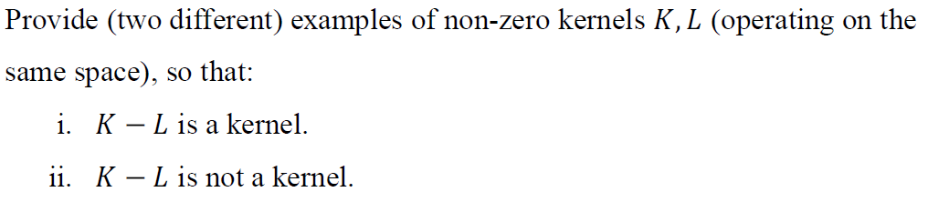

1. Let $x,y∈R^{d}$, the 1st degree homogenous polynomial kernel is:

$$K:R^{d}→R, such that K=\left(x*y\right) where*denotes inner product$$

For $L:R^{d}→R such that L=K$, it holds that:

$K-L=0$ and as such, $∀x,y∈R^{d}:$

$$\left(K-L\right)\left(x,y\right)=0$$

The function $φ:R^{d}→R such that ∀x∈R^{d} φ\left(x\right)=0$ holds:

$$φ\left(x\right)*φ\left(y\right)=0*0=0=\left(K-L\right)\left(x,y\right)$$

Thus $K-L$ is a kernel.

1. Let $x,y∈R^{d}$, the 1st degree homogenous polynomial kernel is:

$$K:R^{d}→R, such that K=\left(x*y\right) where*denotes inner product$$

For $L:R^{d}→R such that L=2K$, it holds that:

$K-L=-K$ and as such, $∀x,y∈R^{d}$:

$$\left(K-L\right)\left(x,y\right)=-K\left(x,y\right)=-\left(x*y\right)$$

Assume by contradiction that $K-L$ is a kernel, thus there is a function $φ:R^{d}→R^{N}$ such that $∀x,y∈R^{d}$ it holds:

$$-K\left(x,y\right)=-\left(x*y\right)=φ\left(x\right)*φ\left(y\right)$$

But, for $x=y=\left[\begin{aligned}1 \\ 1 \\ ⋮ \\ 1\end{aligned}\right]∈R^{d}$:

$$-K\left(x,y\right)=-K\left(x,x\right)=-\left(1+1+…+1\right)=-d≤0$$

But an inner product $φ\left(x\right)*φ\left(x\right)$ is always $≥0⇒$ contradiction.

Thus $K-L$ is not a kernel.

**Question 2**

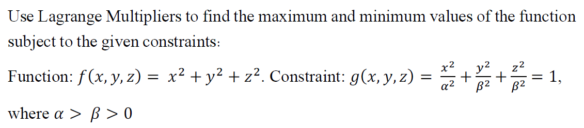

Note that:

$$L\left(x,y,z\right)=x^{2}+y^{2}+z^{2}+λ\left(\frac{x^{2}}{α^{2}}+\frac{y^{2}}{β^{2}}+\frac{z^{2}}{β^{2}}-1\right)$$

$$\frac{∂}{∂x}=2x+\frac{λ}{α^{2}}2x=\left(2+\frac{2λ}{α^{2}}\right)x=0⟹\left(1+\frac{λ}{α^{2}}\right)x=0$$

$$\frac{∂}{∂y}=\left(1+\frac{λ}{β^{2}}\right)y=0$$

$$\frac{∂}{∂z}=\left(1+\frac{λ}{β^{2}}\right)z=0$$

$$\frac{∂}{∂λ}=\frac{x^{2}}{α^{2}}+\frac{y^{2}}{β^{2}}+\frac{z^{2}}{β^{2}}-1=0$$

From the 1st equation, look at two cases:

1st case:

Assume the following –

$$\left(1+\frac{λ}{α^{2}}\right)=0⟹λ=-α^{2}$$

From $α>β$ we get:

$$\left(1+\frac{λ}{β^{2}}\right)=\left(1-\frac{α^{2}}{β^{2}}\right)<0$$

And by plugging the above into the 2nd and 3rd equations, we get:

$$y=z=0$$

By plugging the above into the 4th equation, we get:

$$\frac{x^{2}}{α^{2}}-1=0⇒x^{2}=α^{2}⇒x=±α$$

Thus, the points $p_{1}=\left(α,0,0\right),p_{2}=\left(-α,0,0\right)$ are extremum points, and:

$$f\left(p_{1}\right)=f\left(p_{2}\right)=α^{2}$$

2nd case:

Now we assume the following –

$$x=0$$

From the 2nd equation, look at two sub-cases:

Sub1:

Assume $\left(1+\frac{λ}{β^{2}}\right)=0$, which means $y,z$ can be any numbers that keeps the 4th equation:

$$A=\left\{\left(0,y,z\right) | y^{2}+z^{2}=β^{2}\right\}$$

And therefore, for any $p∈A⇒ f\left(p\right)=β^{2}$.

Sub2:

Assume $y=0$ and plug it into the 4th equation and get:

$$\frac{z^{2}}{β^{2}}-1=0⇒z^{2}=β^{2}⟹z=±β$$

Thus, the points $p_{3}=\left(0,0,-β\right), p_{4}=\left(0,0,β\right)$ are extremum points, and:

$$f\left(p_{3}\right)=f\left(p_{4}\right)=β^{2}⇒p_{3},p_{4}∈A$$

We know that $α>β⟹α^{2}>β^{2}⟹f\left(p_{1}\right)=f\left(p_{2}\right)>f\left(p∈A\right)$. Thus minimum points are $p∈A=\left\{\left(0,y,z\right)|y^{2}+z^{2}=β^{2}\right\}$– for example $p_{3}=\left(0,0,-β\right), p_{4}=\left(0,0,β\right)$

And the maximums are $p_{1}=\left(α,0,0\right), p_{2}=\left(-α,0,0\right)$

**Question 3:**

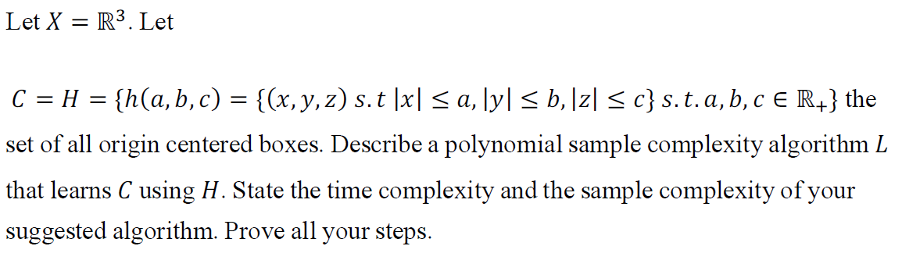

**Consistent Learner:**

Let $D⊆X$ be a sample data set.

Define:

$$a=\begin{aligned}max \\ d∈D:C\left(d\right)=1\end{aligned}\left|d_{x}\right|$$

$$b=\begin{aligned}max \\ d∈D:C\left(d\right)=1\end{aligned}\left|d_{y}\right|$$

$$c=\begin{aligned}max \\ d∈D:C\left(d\right)=1\end{aligned}\left|d_{z}\right|$$

Explanation:

$h$ will be the smallest origin centered box that contains all points $d∈D$ such that $C\left(d\right)=1$.

Return $h\left(a,b,c\right)∈H$.

Proof of correction:

Let $d=\left(x,y,z\right)∈D$ and assume $C\left(d\right)=1$, we’ll prove that $h\left(d\right)=1$, note that by the selection of $h$, it holds that:

$$\left|x\right|≤a, \left|y\right|≤b, \left|z\right|≤c$$

Therefore, the point $d$ is inside the centered box $h\left(a,b,c\right)$ which means $h\left(d\right)=1.$

Now let $d=\left(x,y,z\right)∈D$ and assume $C\left(d\right)=0$, we’ll prove that $h\left(d\right)=0$, note that by the definition of C and the selection of $h$, it holds that:

$$\left|x\right|>a or \left|y\right|>b or \left|z\right|>c$$

Therefore, the point $d$ is outside the centered box $h\left(a,b,c\right)$ which means $h\left(d\right)=0.$

**Time Complexity:**

$$O\left(m\right)-running on all the training data points$$

**Sample Complexity:**

Let $a^{'},b^{'},c^{'}$ be the values of the target origin centered box, meaning:

$$∀p∈R^{3}, C\left(p\right)=1 iff \left(\left|p_{x}\right|≤a^{'}∧\left|p_{y}\right| ≤b^{'}∧\left|p_{z}\right|≤c^{'}\right)$$

Note that there is a simple and efficient way to come up with the hypothesis $h$ as we defined above.

We will now bound all training datasets, $D$, that can lead to $h=L\left(D\right)$ with error rate $Err\left(h,c\right)>ε$ into a union of sets characterizable by regions that they do not visit.

We will build cuboid on each face of the $h$ cuboid with volume such that the probability for an instance to be in that cuboid is $\frac{ε}{6}$.

For $1≤i≤6$ we now have $C_{i}$ a cuboid such that $P\left(C_{i}\right)=\frac{ε}{6}$.

Consider a training data $D∈X^{m}$:

$$P\left(\left\{D∈X^{m}:Err\left(h=L\left(D\right),c\right)>ε\right\}\right)≤\sum_{i=1}^{6}{{\left(P\left(X-C_{i}\right)\right)}^{m}}≤6{\left(1-\frac{ε}{6}\right)}^{m}≤6\exp\left(-\frac{mε}{6}\right)$$

And note that with sample size $m≥\frac{6\ln\left(\frac{1}{δ}\right)}{ε}$, we get:

$$\exp\left(-\frac{εm}{6}\right)≤\exp\left(-\ln\left(\frac{1}{δ}\right)\right)=\exp\left(\ln\left(δ\right)\right)=δ$$

**Illustration – blue cubiod is h, larger cudboid is C:**

